**WEATHER WAVE**

**DOCUMENTATION**

**Introduction:**

Welcome to the documentation for weather website built using Spring Boot and Angular! Our weather website provides users with up-to-date weather information, including current conditions and forecasts, to help them plan their activities and stay informed about weather changes in their area.

**Purpose of the Project:**

This documentation serves as a comprehensive guide for users and developers to understand the functionality, architecture, and usage of our weather website. Whether you're a first-time visitor looking to explore the features or a developer seeking to integrate with our APIs, this documentation will provide you with all the necessary information to get started and make the most out of our platform. From installation and setup instructions to detailed usage guides and API documentation, we aim to empower users and developers to effectively utilize our weather services.

**Tools Used:**

1. **IntelliJ IDEA**:
   * Integrated development environment (IDE) for Java development.
   * Used for backend development with Spring Boot.
2. **Visual Studio Code (VSCode)**:
   * Lightweight code editor with robust features.
   * Ideal for frontend development with Angular.
3. **Weather API**:
   * Third-party weather API provider for accessing weather data.
   * Obtain API credentials for integrating weather data into the backend.
4. **Web Browser**:
   * Use a modern web browser like Google Chrome or Mozilla Firefox to access and test the Weather App frontend.

**Key Features:**

1. **Current Weather**:
   * Get real-time updates on weather conditions for any city.
   * Access essential data like temperature, humidity, and wind speed instantly.
2. **Historical Data**:
   * Dive into past weather records for any date and location.
   * Review historical weather patterns to better understand climate trends.
3. **Extended Forecast**:
   * Plan with a detailed 15-day weather forecast.
   * Stay informed about upcoming weather changes and prepare accordingly.
4. **Third-Party API Integration**:
   * Utilizes a third-party API for seamless weather data retrieval.
   * Ensures accurate and reliable weather information for users.

**Flow Chart:**

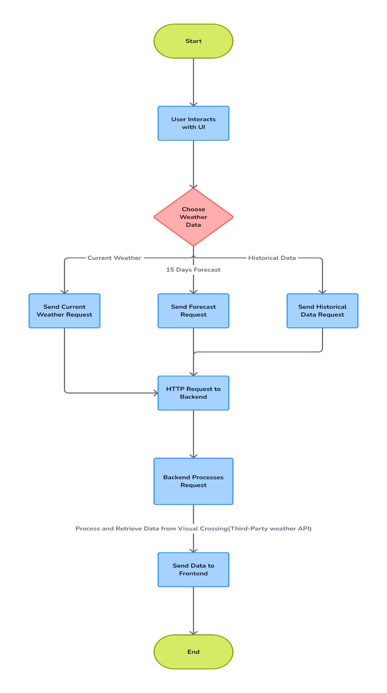

**Usage:**

1. **Accessing Weather Information:**
   * Open the Weather App in your preferred web browser.
2. **Selecting Weather Type:**
   * Enter the name of the city you want to check the weather for.
   * Choose the type of weather information you need: Current, Historical, or Next 15 Days Forecast.
3. **Viewing Weather Data:**
   * Click the corresponding button to retrieve and display the weather data.
   * Explore detailed weather information presented on the frontend interface.